Owner:
File: | J:\PATENTS SHARED\CONTENTCREATIONSYSTEM\IP SEARCH TOOLS\TRADEMARK SEARCH\TM ADVANCED SEARCH.DOCX
File Name: | TM ADVANCED SEARCH
Last Saved by: | Yvonne Cassidy

Navigation Path | HOME \IP Search Tools\Trademark Search\TM Advanced Search
Page Title | Trade Mark Advanced Search
Focus Keywords | Trade Mark; Advanced; Search; database
Page Summary | A trade mark database advanced search can be conducted using text, applicant/proprietor/holder details, good and service class numbers and/or figurative codes.
Page Content | 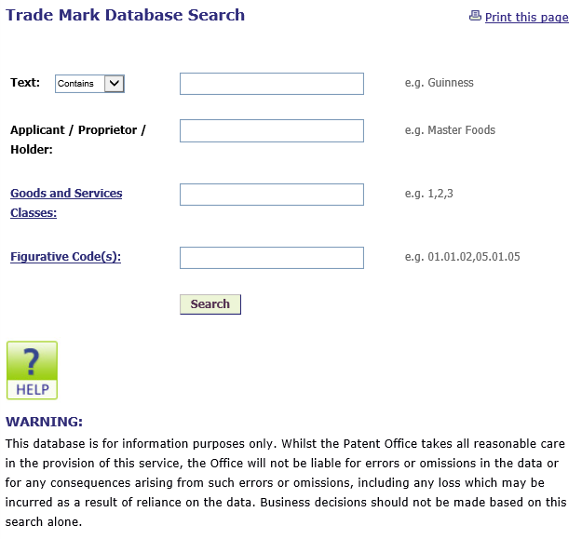
SEO Meta Title (max 60 Characters) | Patents Office | IP Search Tools | Trade Marks
SEO Meta Description (Max 160 Characters) | A trade mark database advanced search can be conducted using text, applicant/proprietor/holder details, good and service class numbers and/or figurative codes.
Any specific image(s) or logo(s) are required on this page
PDF Downloads (file_name.jpg)
Video (YouTube url)

