Owner:
File: | J:\PATENTS SHARED\CONTENTCREATIONSYSTEM\IP SEARCH TOOLS\DESIGN SEARCH\DS ADVANCED SEARCH.DOCX
File Name: | DS ADVANCED SEARCH
Last Saved by: | Yvonne Cassidy

Navigation Path | HOME \IP Search Tools\Design Search\DS Advanced Search
Page Title | Design Advanced Search
Focus Keywords | Design; search; advanced; published;
Page Summary | An advanced search of the Design database can be conducted using the design number, publication date, keywords, class number, author and/or proprietor.
Page Content | Only published designs filed under the Industrial Designs Act 2001 may be viewed.  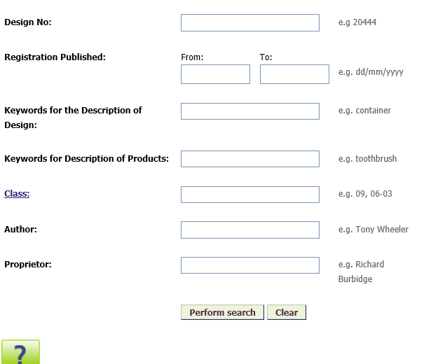  WARNING:  This database is for information purposes only. Whilst the Patent Office takes all reasonable care in the provision of this service, the Office will not be liable for errors or omissions in the data or for any consequences arising from such errors or omissions, including any loss which may be incurred as a result of reliance on the data. Business decisions should not be made based on this search alone.
SEO Meta Title (max 60 Characters) | Patents Office | IP Search Tools | Design Search
SEO Meta Description (Max 160 Characters) | An advanced search of the Design database can be conducted using the design number, publication date, keywords, class number, author and/or proprietor.
Any specific image(s) or logo(s) are required on this page
PDF Downloads (file_name.jpg)
Video (YouTube url)

