World Intellectual Property Day, 26th of April 2024

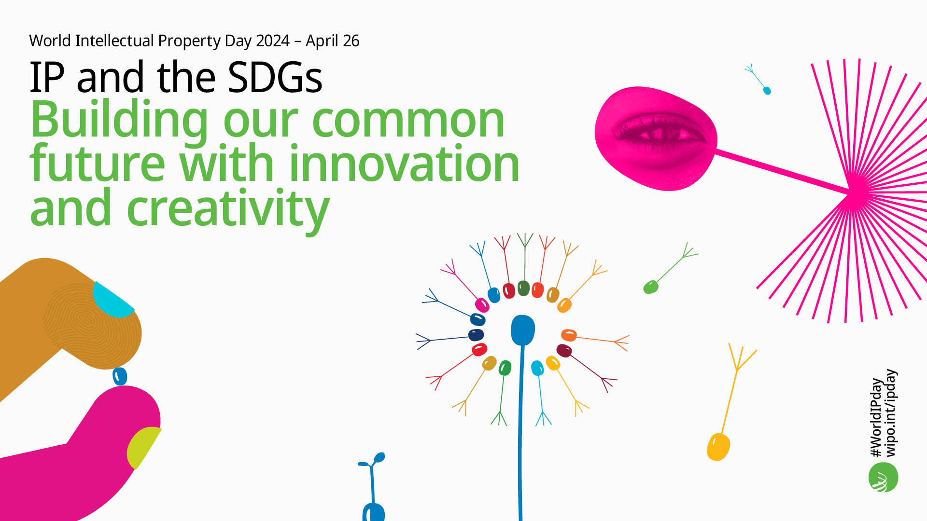

World IP Day is celebrated annually on 26 April to increase general understanding of intellectual property. This provides a unique opportunity for IP Offices worldwide to highlight the role that IP rights, such as Patents, Trade Marks, Industrial Designs, and Copyright play in encouraging innovation and creativity. This year’s theme is on “IP and the Sustainable Development Goals - Building our common future with innovation and creativity”.

In collaboration with Enterprise Ireland, IPOI contacted companies who operate within the sustainability sphere and who used intellectual property as part of their business strategy. We also contacted there inspiring students from Loreto Secondary School, Balbriggan, Co. Dublin who won the Best Group Award at the 2024 BT Young Scientist and Technology Exhibition and who have patented their invention.
Their videos attached outline their SDG and IP story:
1. Highlighting the Clean Water and Sanitation SDG are TelLab & Aquamonitrix from Tullow, Co. Carlow, who specialise in water quality and are dedicated to providing water resource managers with accurate, simple and affordable analysers for nutrient monitoring. John Mc Grath, Sales Director explains the importance of intellectual property for their company, from when they registered their first Intellectual Property to how the application of their technology contributes to providing clean water.

World IP Day Video by John McGrath, Sales Director of TelLab & Aquanmonitrix
2. Highlighting the SDGs of Climate Change and Life on Land are i0/AGRI from Canningstown, Co. Cavan, who specialise in the innovative task of eliminating and controlling odours and emissions which allows farmers to increase productivity levels while protecting the environment. Co-founder Sandra Thompson outlines what they do, why they decided to register their intellectual property rights and how they contribute to the Sustainable development goals.
World IP Day Video by Co-founder Sandra Thompson of iO/AGRI
3. In particular we are delighted to showcase Olivia O’ Shea, Abigail O’ Brien-Murray and Erica O’ Brien-Murray, students from Loreto Secondary School, Balbriggan, Co. Dublin. These inspiring young innovators won the prestigious Best Group Award at the 2024 BT Young Scientist and Technology Exhibition with their project “Let’s Save the Common Ash! A Continued Study”. In particular they recognised that protecting IP was a necessary step in securing their treatment for future relevance ahead of the competition. They were granted the patent for their innovative treatment for ash tree dieback that slows the disease up to 92% with no effect on the environment. 950 species of woodland and trees are dependent on the Ash Tree and if the Ash Tree is unable to thrive, 45 species could end up extinct.
World IP Day Video by Olivia O'Shea, Abigail O'Brien Murray, and Erica O'Brien Murray
Further information on how to protect your Intellectual Property Rights can be found at Intellectual Property Office of Ireland website.
Further information on World IP Day 2024 can be found at World Intellectual Property Day April 26, 2024 (wipo.int) and Sustainable Development Goals

#WorldIPDay #EnterpriseIreland #intellectualproperty #euipo

